McDonald’s Event Planner a Digital Integrated System For Birthday Parties, Business Meetings, and Reservations In Surigao Branch

Capstone Project Presented to
The Faculty of the College of Computing & Information Sciences
Surigao del Norte State University
Surigao City

In Partial Fulfillment
Of the Requirements for the Degree
Bachelor of Science in Information Technology

By

JAY CHRISTIAN ESTAMPA
HARDERLY PANANGGANAN
CARA REGINA YANOC

May 2026
1. INTRODUCTION
The lack of an efficient, centralized system for managing event reservations at fast-food establishments like McDonald’s has made it difficult to organize birthday parties, business meetings, and other events. This study aims to design and develop a McDonald’s Event Planner, a digital system that streamlines reservations and event management processes. Traditionally, event planning in such establishments relies on manual booking, which is prone to errors, double bookings, and miscommunication. These inefficiencies affect both customers and staff, leading to dissatisfaction and operational delays. In the context of modern digital transformation, the absence of an automated system limits service quality and competitiveness. This study seeks to address these issues specifically within McDonald’s branches in the local community. Research questions: (1) What are the current problems encountered in manual event reservation systems in McDonald’s? (2) How can a digital event planner system improve the efficiency of managing reservations? (3) What features are necessary to ensure usability and reliability of the proposed system? (4) How effective is the system in enhancing customer satisfaction and operational performance?
In today’s fast-paced environment, customers expect convenience and efficiency when booking events. However, many McDonald’s branches still rely on manual reservation systems such as logbooks or verbal confirmations, which often lead to scheduling conflicts and lack of proper documentation. These traditional methods hinder effective communication between staff and customers and may result in poor event coordination. The need for a digital solution becomes more critical as the demand for organized and hassle-free event planning continues to grow.
Furthermore, digital systems provide advantages such as real-time booking, automated scheduling, and accurate record-keeping. Implementing an event planner system can significantly reduce human error, improve coordination, and enhance customer experience. It also allows management to monitor reservations, generate reports, and optimize resource allocation. This innovation supports the broader goal of integrating technology into business operations to improve efficiency and service delivery.
The proposed McDonald’s Event Planner will serve as a centralized platform where users can book events, select packages, and manage reservations conveniently. Staff members can access updated schedules, confirm bookings, and handle event logistics efficiently. This system is expected to improve workflow, reduce operational challenges, and provide a better overall experience for both customers and employees.
Ultimately, this study contributes to the advancement of digital solutions in the food service industry, particularly in event management. By addressing the limitations of manual systems, the project aims to provide a reliable and user-friendly platform that enhances service quality. The findings of this study will also serve as a reference for future researchers and developers interested in improving event reservation systems in similar business environments.

1.1 Project Context
This project is developed in response to the challenges faced by McDonald’s branches in managing event reservations manually. The current process often involves physical logbooks, phone calls, or in-person bookings, which can result in errors, double bookings, and inefficient coordination. In a growing digital environment, such traditional methods are no longer sufficient to meet customer expectations.
The McDonald’s Event Planner is important in the context of the local community as it enhances service efficiency and customer satisfaction. By introducing a digital platform, the project supports business operations through automation and organized data management. It also aligns with the increasing demand for digital solutions in fast-food services, particularly in event planning and reservations.

1.2 Purpose and Description
The purpose of this project is to develop a digital event planning and reservation system for McDonald’s that allows customers to easily book events such as birthday parties, business meetings, and other gatherings. The system aims to replace manual processes with an automated platform that ensures accuracy and efficiency.
The McDonald’s Event Planner enables users to select event packages, choose schedules, and submit reservations online. It also provides staff with tools to manage bookings, confirm schedules, and generate reports. The system is designed to be user-friendly, reliable, and accessible, improving both customer experience and operational workflow.

1.3 General Objectives of the Study
This study aims to design and develop a digital event reservation system for McDonald’s that improves efficiency, accuracy, and user satisfaction.
- To develop a McDonald’s Event Planner system for managing event reservations.
- To provide an automated platform for booking birthday parties, meetings, and other events.
- To evaluate the system in terms of usability, reliability, and efficiency.
- To improve customer experience and operational performance through digital transformation.

1.4 Scope and Limitations
The system is designed to manage event reservations specifically for McDonald’s branches. It includes features such as event booking, schedule management, package selection, and reservation tracking. The system will be accessible to customers and staff for managing event-related transactions.
However, the system has certain limitations. It will not include payment integration, advanced analytics, or integration with other corporate systems. The project will focus only on selected McDonald’s branches within the local area. Additionally, the system will be developed as a prototype and may require further enhancements for full-scale deployment.

2. RELATED LITERATURE
This chapter presents the review of local and foreign studies related to the development of the McDonald's Event Planner, a digital integrated system for birthday parties, business meetings, and reservations in Surigao Branch. The reviewed literature focuses on online reservation systems, hotel and resort booking platforms, event management systems, restaurant automation, mobile reservation applications, and digital hospitality services. These studies were examined to identify existing practices, system features, benefits, and research gaps that support the development of the proposed system.

2.1 Local Related Literature
Capuno et al. (2021) developed an online reservation system with SMS notification for event management. Their study showed that automated reservation and notification features improve booking efficiency, reduce scheduling conflicts, and provide faster communication between the organization and its clients. This is related to the proposed McDonald's Event Planner because the system also aims to improve event booking through organized records and clear reservation updates.
Esguerra and Arreza (2021) examined the use of digital hotel booking platforms in Cebu City and found that ease of navigation and simplified booking procedures significantly influence customer satisfaction. Their findings suggest that users are more willing to use digital reservation platforms when the process is simple and convenient. This supports the need for a user-friendly interface in the proposed system.
Felicen and Ylagan (2020) explained that computerized reservation systems improve operational efficiency and customer service delivery in tourism-related businesses. Their study shows that computer-based reservation tools can reduce manual work and make transactions easier to monitor. This is relevant to the proposed system because McDonald's event reservations also require accurate record keeping and efficient service handling.
Ramento et al. (2024) developed a web-based reservation and management system for Nature Spring Resort. Their study revealed that digital reservation systems improve customer convenience and booking management by making records easier to organize and access. This supports the development of the proposed system because the McDonald's Event Planner also needs a centralized platform for managing event reservations.
Calpito et al. (2020) developed a web-based and mobile hotel reservation system with analytics. Their findings showed that web and mobile accessibility improves customer engagement, reservation monitoring, and management decision-making. This literature is related to the proposed system because the McDonald's Event Planner includes web and mobile access for customers, staff, and administrators.
Felicen (2024) highlighted that innovation and digital transformation improve efficiency in hospitality and catering businesses. The study emphasized that digital systems help businesses organize service processes and respond better to customer needs. This supports the proposed project because McDonald's event services also require organized scheduling, package selection, and customer coordination.
Dublado et al. (2020) emphasized that computerized guest management systems improve reservation accuracy and reduce manual workload. Their study showed that digital records lessen the possibility of misplaced information and manual errors. This finding supports the proposed system because accurate reservation records are necessary to prevent confusion, double booking, and delayed confirmation.
Munoz (2023) found that online reviews and digital platforms influence customer decisions in accommodation booking. This shows that customers consider online information, convenience, and digital service quality when making reservations. The finding is relevant to the proposed McDonald's Event Planner because a reliable digital platform can increase customer confidence in booking events.
Leona (2023) developed the AppStay reservation system, which improved accessibility and real-time reservation management. The study showed that web-based reservation tools allow users to access services more conveniently while helping administrators monitor records. This supports the proposed system because customers need an accessible platform for creating and tracking event reservations.
Monterey (2021) explained that service quality strongly affects customer satisfaction in online travel agencies. The study highlights the importance of reliable information, convenient access, and responsive service in digital booking platforms. This is related to the proposed system because customer satisfaction depends on how smoothly users can complete and monitor their reservations.
Deocampo et al. (2020) found that online resort service systems improve communication and reservation convenience. Their study showed that digital platforms help customers submit booking requests and help staff manage service information. This supports the proposed McDonald's Event Planner because customer communication and booking convenience are important in event reservation services.
Caritos (2024) discussed how digital transformation improves hotel reservation management and customer engagement. The study explained that replacing manual processes with digital systems can make reservation handling faster and more organized. This is relevant to the proposed system because it aims to digitize event reservation management for McDonald's Surigao Branch.
Vega (2024) developed an online facility reservation system that reduced overlapping reservations and improved availability monitoring. This finding is important to the proposed system because one of its main goals is to prevent double booking through schedule checking and centralized reservation records.
Villanueva (2024) explained that online reservation management systems improve scheduling efficiency and simplify booking processes. The study supports the idea that automated systems can help businesses organize reservations more effectively than manual methods. This is connected to the proposed project because McDonald's event reservations require proper scheduling and booking status monitoring.
Sabaulan (2023) emphasized that digital systems improve management practices in hospitality industries. Although the study focused on hospitality practices, it supports the broader idea that technology can help service establishments improve operations, customer service, and management efficiency.

2.2 Foreign Related Literature
Egigogo et al. (2024) developed a computerized restaurant table booking system that improved reservation efficiency and reduced booking conflicts. Their study showed that computerized systems help restaurant staff organize reservations more accurately. This is related to the proposed McDonald's Event Planner because both systems focus on improving food-service reservation management.
Gaur (2024) explained that online reservation systems improve operational efficiency and customer convenience in hospitality businesses. The study emphasized that digital platforms reduce manual workload and make reservation processing faster. This supports the proposed system because it aims to replace manual event reservation handling with a more organized digital process.
Halkiopoulos et al. (2020) found that accessibility and ease of use strongly affect online booking decisions in tourism systems. Their study suggests that users are more likely to use a reservation platform when it is simple and accessible. This supports the need for a clear booking flow in the proposed system.
Mohd Roseli and Hamid Ali (2024) developed a web-based cafe reservation system that improved booking convenience and reservation monitoring. The study demonstrates that web-based platforms are useful in food-service establishments that need to manage reservations. This is relevant to the proposed McDonald's Event Planner because it is also designed for a food-service setting.
Deksne et al. (2021) found that restaurant automation systems improve operational efficiency and customer flow management. Their findings show that automation can support faster service delivery and better coordination among staff. This is useful for the proposed system because event reservations require staff preparation and service monitoring.
Ganiyu et al. (2024) explained that online event booking systems reduce operational costs and improve reservation accessibility. Their study supports the use of online platforms for event-related reservations because customers can book remotely and administrators can manage records more efficiently. This is directly related to the proposed McDonald's Event Planner.
Ozturk et al. (2020) emphasized that convenience and system usability improve customer loyalty in mobile booking platforms. This finding supports the proposed mobile application because customers are more likely to use a system that is convenient and easy to operate.
Gangurde and Kshirsagar (2024) introduced smart dining systems integrating reservations and food pre-ordering. Their study showed that combining booking and food selection improves customer experience and service preparation. This is closely related to the proposed system because customers can select event packages, menu items, and add-ons during the booking process.
Garcia et al. (2024) highlighted that digital reservation platforms improve hospitality management and customer engagement. Their study supports the use of digital systems to improve communication, reservation monitoring, and service delivery. This is relevant to the proposed system because it aims to improve the event reservation workflow for customers, staff, and administrators.
Sahara et al. (2024) developed a web-based reservation system that improved catering service efficiency. Their study shows that digital reservation platforms are useful for food-service events where schedules, customer information, and service requirements must be organized. This supports the proposed McDonald's Event Planner because it also handles event-based food service reservations.

2.3 Synthesis and Research Gap
The reviewed studies show that digital reservation systems improve booking efficiency, customer convenience, record accuracy, operational monitoring, and service delivery. Local studies prove that online reservation systems are useful in hotels, resorts, travel agencies, event centers, and facility management. Foreign studies further show that restaurant automation, cafe booking systems, event booking platforms, catering reservation systems, and mobile booking applications help reduce manual workload and improve customer experience.
However, most of the reviewed systems focus on hotels, resorts, travel agencies, restaurant table reservations, cafes, catering businesses, or general event facilities. There is limited focus on a digital reservation system specifically designed for fast-food event services such as McDonald's birthday parties, business meetings, and branch-based reservations. The proposed McDonald's Event Planner addresses this gap by integrating event booking, branch availability checking, package and menu selection, payment proof upload, customer dashboard, staff operations, and administrator approval in one web and mobile system.
3. TECHNICAL BACKGROUND
The proposed McDonald's Reservation System is a web and mobile-based reservation management system designed to support customers, branch staff, and administrators in handling event bookings. The technical foundation of the project is centered on a Laravel backend, an Inertia and Vue.js web interface, and an Expo React Native mobile application. These technologies work together to provide online booking, branch availability checking, payment proof uploading, booking approval, staff check-in, service monitoring, and customer account management.
The system follows a client-server architecture. The client side is composed of the web application and the mobile application, while the server side is responsible for authentication, reservation processing, catalog management, business rules, and database transactions. This structure allows the system to separate the user interface from the application logic, making it easier to maintain, test, and improve the project as additional reservation features are introduced.
For the web platform, the project uses PHP with the Laravel framework. Laravel provides routing, controllers, models, validation, authentication support, file storage, and database access through Eloquent ORM. These features are important because the reservation system needs to manage different types of data such as users, reservations, branches, packages, rooms, menu bundles, add-ons, payment proof files, and staff assignments. Laravel also supports role-based workflows, allowing customer, staff, and admin features to be separated while still sharing the same backend.
The web user interface is developed using Vue.js with Inertia.js. Vue.js is used to build reactive pages such as the booking wizard, customer dashboard, admin booking review, staff dashboard, availability calendar, and profile management screens. Inertia.js connects Laravel and Vue without requiring a separate single-page application backend, allowing the system to behave like a modern application while still using Laravel routes and controllers. Tailwind CSS is used for styling because it provides reusable utility classes for creating responsive layouts and consistent interface components.
The mobile application is developed using Expo and React Native. Expo provides the development environment for building the mobile app, while React Native allows the project to create native-style screens using TypeScript and reusable components. The mobile app communicates with the Laravel backend through API routes. It includes customer booking functions, dashboard viewing, profile management, staff operations, and admin actions such as updating booking status, assigning crew, and managing branch or catalog information.
The system uses Laravel Sanctum for API authentication. When a mobile user logs in or registers, the backend issues a secure token that is included in succeeding API requests. This token-based approach protects private functions such as reservation creation, cancellation, rescheduling, staff check-in, profile updates, and admin management. On the mobile side, AsyncStorage is used to store the session token and cached user data so that the app can restore a user session and reduce repeated loading.
The database layer stores the main records needed by the system. Important entities include User, Reservation, Branch, BookingPackage, EventType, RoomOption, MenuBundle, MenuItem, AddOn, and BookingSetting. The Reservation model contains booking details such as event date, time, duration, branch, number of guests, selected package, manual menu items, add-ons, payment proof path, total amount, booking reference, check-in code, booking status, and service status. This structure supports both customer-facing booking and operations-facing monitoring.
Several technical concepts are applied in the project. First, role-based access control is used to separate customer, staff, and administrator capabilities. Second, API-based communication allows the mobile app to reuse the same backend data and business rules used by the web application. Third, reservation availability logic helps prevent scheduling conflicts by checking branch, date, time, duration, and capacity limits. Fourth, file upload handling is used for payment proof submission. Lastly, QR or booking pass functionality supports faster event check-in by giving staff a code-based way to verify arriving customers.

Technical Tools and Frameworks Used
Component | Technology | Purpose in the System
Backend Framework | PHP and Laravel 9 | Handles routing, controllers, validation, models, authentication, business rules, and server-side reservation processing.
Web Frontend | Vue.js, Inertia.js, Vite | Provides responsive customer, staff, and admin web pages without separating the frontend from the Laravel application.
Mobile Frontend | Expo, React Native, TypeScript | Provides the mobile application for booking, dashboard viewing, staff operations, and selected admin functions.
Styling | Tailwind CSS and reusable UI components | Creates consistent layouts, forms, dashboards, status badges, and responsive visual design.
API Layer | Laravel API routes and JSON responses | Connects the mobile application to the backend for login, booking, profile, staff, and admin functions.
Authentication | Laravel Sanctum and AsyncStorage | Secures API requests through tokens and stores the mobile session locally on the device.
Database Layer | Relational database through Eloquent ORM | Stores users, reservations, branches, packages, menu items, add-ons, settings, and operational records.
File Storage | Laravel storage for payment proof files | Stores uploaded proof of payment and links it to the reservation record for admin review.

3.1 IPO Conceptual Framework
The conceptual framework of the proposed McDonald's Event Planner is presented using the Input-Process-Output (IPO) model. This model explains how the system receives reservation-related data from customers, staff, and administrators, processes the data through the web and mobile application workflow, and produces organized booking outputs that support event reservation management. The IPO framework is appropriate for this study because the proposed system focuses on transforming manual booking information into accurate, traceable, and accessible digital records.
Input refers to the information entered into the system before a reservation can be processed. For customers, the inputs include account details, selected event type, preferred McDonald's branch, event date, start time, duration, number of guests, room option, package, menu bundle, menu items, add-ons, special notes, and uploaded payment proof. For staff and administrators, the inputs include booking status updates, crew assignment, branch information, package details, room availability, menu records, and service progress updates. These inputs represent the data needed by the system to create and manage event reservations properly.
Process refers to the system operations that convert the entered data into useful reservation records. The Laravel backend authenticates users, validates booking details, checks availability, prevents conflicting schedules, calculates reservation totals, stores records in the database, manages uploaded payment proof, and sends updated booking information to the dashboards. The Vue.js web interface and React Native mobile application allow users to interact with these processes through booking forms, dashboards, staff tools, and administrator management screens. Administrators review pending reservations, approve or reject bookings, assign crew, and maintain branch and catalog information, while staff members handle check-in and service status updates.
Output refers to the information and results generated after the system completes its processing. The outputs include booking reference numbers, pending or confirmed reservation statuses, customer dashboard records, QR or booking pass details, updated availability schedules, staff preparation lists, service status records, administrator booking reports, and organized reservation histories. These outputs help customers monitor their reservations, help staff prepare and manage events, and help administrators make better decisions using accurate and centralized booking information.
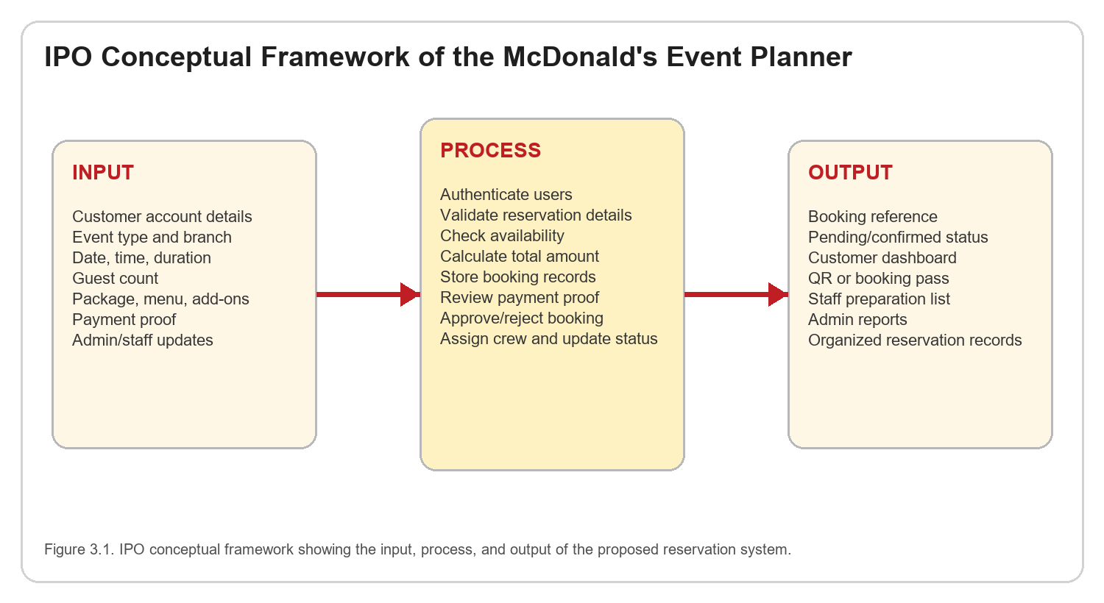
Figure 3.1. IPO Conceptual Framework of the McDonald's Event Planner
Overall, the IPO conceptual framework shows that the McDonald's Event Planner starts with user and reservation inputs, processes them through system validation, availability checking, database storage, booking review, and operational updates, and ends with reliable outputs for customers, staff, and administrators. Through this flow, the proposed system addresses the problems of manual reservation handling, including double booking, unclear records, slow confirmation, and difficulty in monitoring event schedules.
4. METHODOLOGY
This chapter presents the methodology used in the design and development of the proposed McDonald's Reservation System. The project followed the Rapid Application Development (RAD) methodology because the system requires quick prototyping, repeated user feedback, and continuous improvement of interface and functional requirements. RAD is suitable for this study because the reservation process involves several user groups, including customers, staff, and administrators, whose needs must be reviewed through visible prototypes and working software iterations.
Based on Systems Analysis and Design concepts, the project began by identifying the current reservation problems, defining the proposed system scope, analyzing user roles, designing the system flow, developing prototypes, implementing the software, and evaluating the output. The methodology focuses on converting the existing manual or semi-manual reservation process into a structured digital workflow where booking requests, payment proof, schedule checking, admin approval, and staff event handling can be managed in one system.
The RAD model was selected because it supports active participation from stakeholders during development. Instead of completing the entire system before showing it to users, the researchers created prototype screens and revised the workflow according to feedback. This approach helped the team identify missing features, unclear interface labels, possible booking conflicts, and operational needs before finalizing the Laravel web application and Expo React Native mobile application.
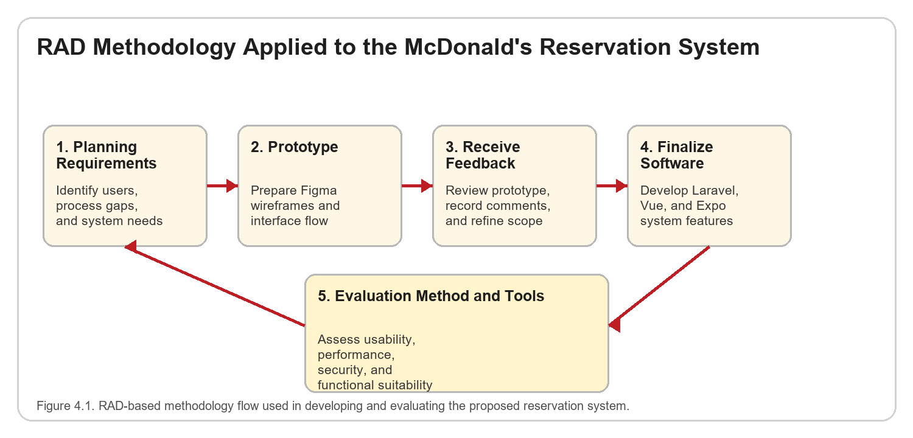
Figure 4.1. RAD Methodology Applied to the Proposed System

Summary of Methodology Activities
RAD Phase | Main Activity | Expected Output
Planning Requirements | Analyze reservation problems, identify users, and list functional and non-functional requirements. | Requirements list, user roles, process scope, and feature priorities.
Prototype | Create low-fidelity and interface flow designs for customer, staff, and admin screens. | Figma wireframes, proposed screen flow, and prototype navigation.
Receive Feedback | Present the prototype to possible users and improve the design based on comments. | Revised prototype, clarified features, and improved workflow.
Finalize Software | Develop the Laravel web system, Expo mobile app, database, API routes, and authentication. | Working reservation system with customer, staff, and admin modules.
Evaluation | Test the system using selected ISO 25010 criteria, task observation, questionnaires, and error logs. | Evaluation results, usability feedback, and recommendations.

4.1. Planning Requirements
In the planning requirements phase, the researchers identified the main problems in handling McDonald's event reservations. The study considered the needs of customers who want a convenient way to book events, staff members who need organized schedules and check-in records, and administrators who need a reliable dashboard for reviewing bookings, branches, packages, reports, and availability. The purpose of this phase was to define what the system should do and what limits should be observed during development.
Data for requirements planning may be gathered through informal interviews, observation of the existing reservation process, review of current booking forms or procedures, and consultation with potential users. The gathered information is then translated into functional and non-functional requirements. Functional requirements describe the features the system must provide, while non-functional requirements describe quality attributes such as usability, security, reliability, accessibility, and performance.
Key requirements included:
- Customer registration, login, profile management, and secure session handling.
- Online reservation creation with event type, branch, date, time, duration, room choice, guest count, package, menu items, add-ons, notes, and payment proof upload.
- Availability checking to help prevent booking conflicts based on branch, date, time, duration, and capacity.
- Customer dashboard for viewing booking status, reservation details, rescheduling, cancellation, and QR or booking pass access.
- Staff dashboard for daily event preparation, guest check-in, service status updates, and service adjustments.
- Admin dashboard for pending booking review, confirmation, rejection, crew assignment, branch management, catalog management, availability monitoring, reports, and user account management.
- Secure authentication and role-based access control for customer, staff, and administrator users.
- Database storage for users, reservations, branches, packages, menu selections, add-ons, payment proof paths, booking references, and check-in codes.
At the end of this phase, the researchers defined the system boundary. The proposed system focuses on reservation management, booking monitoring, staff operations, and admin control. It does not aim to replace all McDonald's point-of-sale or enterprise systems. This limitation keeps the project manageable while still addressing the main reservation workflow identified in the study.

4.2. Prototype
In the prototype phase, the researchers prepared a low-fidelity design to represent the proposed system before full software development. Figma was used to organize the interface flow, screen layout, and user navigation for the customer, staff, and admin modules. The prototype served as a visual guide for understanding how users would move from one screen to another, such as from login to booking, from booking confirmation to dashboard, and from admin review to confirmed events.
The prototype was important because it helped the researchers evaluate the system design before coding. Through wireframes, the team could check whether the booking steps were understandable, whether the fields were arranged logically, and whether the admin and staff screens contained the needed information. This reduced the risk of developing features that users might find confusing or incomplete.
Mock-up elements created:
- Landing or home screen showing booking entry points and event options.
- Login and registration screens for customer access.
- Customer booking wizard for event details, branch selection, schedule, package, menu, add-ons, payment proof, and review.
- Customer dashboard, booking details, reschedule option, cancellation option, and QR or booking pass screen.
- Staff dashboard with daily events, check-in input, preparation list, and service status update controls.
- Admin dashboard with booking statistics, pending booking review, branch management, availability calendar, catalog management, reports, timeline, and account management.
- Mobile-first screens for the Expo React Native application and responsive layouts for web users.
The prototype also supported SAD modeling because it made the proposed process visible. It helped connect the requirements gathered in the planning phase to concrete interface elements, data inputs, and expected outputs. The prototype, therefore, acted as a bridge between system analysis and actual system implementation.

4.3. Receive Feedback
After preparing the prototype, the researchers presented the design to possible users and stakeholders for comments and suggestions. The feedback phase focused on checking whether the proposed workflow was understandable, complete, and practical for real reservation activities. Users were asked to review the booking steps, dashboard information, admin approval flow, staff check-in process, and general screen layout.
Feedback gathered may include suggestions such as:
- Simplifying the booking wizard so customers can complete reservation details step by step.
- Adding clearer status labels for pending, confirmed, cancelled, completed, and rejected reservations.
- Providing an availability calendar to help administrators monitor booked and open dates.
- Adding payment proof upload so administrators can review reservation payments before confirmation.
- Including a QR or booking pass feature to speed up guest verification during event check-in.
- Improving staff screens by showing daily events, preparation lists, and service status controls.
- Making the interface mobile-friendly for customers and staff who may use phones during booking or operations.
The researchers revised the prototype and feature priorities based on the feedback. Changes were made to improve navigation, reduce confusing steps, and ensure that customer, staff, and admin users each had access to the information they needed. This phase reflects the RAD principle of iterative improvement, where the system design evolves through user comments before final implementation.

4.4. Finalize Software
In the final software phase, the researchers implemented the system using the selected technologies identified in the technical background. The backend was developed using PHP and Laravel, while the web interface used Vue.js, Inertia.js, Vite, and Tailwind CSS. The mobile application was developed using Expo, React Native, and TypeScript. The system database was structured through Laravel migrations and Eloquent models to manage users, reservations, branches, packages, menu items, add-ons, booking settings, and other operational records.
The final application was developed using:
- Laravel for routing, controllers, validation, authentication, database models, file upload handling, and business logic.
- Vue.js with Inertia.js for the responsive web interface, including customer, staff, and admin dashboards.
- Expo and React Native with TypeScript for the mobile application interface and API-driven mobile workflows.
- Laravel Sanctum for secure mobile API authentication using token-based access.
- Tailwind CSS for consistent layout, spacing, colors, buttons, forms, cards, and status indicators.
- Relational database tables and Eloquent ORM for storing system records and managing relationships.
- Figma for prototype design and interface planning before implementation.
The finalized system included customer booking, dashboard viewing, payment proof upload, booking reschedule and cancellation, QR or booking pass access, staff check-in, service status updates, admin booking review, crew assignment, branch management, catalog management, availability monitoring, reports, and account management. The mobile application reused the Laravel backend through API endpoints, allowing the project to maintain consistent data and rules between the web and mobile platforms.
Internal testing was conducted during development to check form validation, login and registration, API communication, booking creation, admin approval, staff check-in, file upload behavior, and role-based access. Errors found during testing were corrected by improving validation rules, interface messages, database handling, and user navigation. This ensured that the final version was more stable and easier to use before evaluation.

4.5 Evaluation Method and Tools
To assess the quality of the proposed McDonald's Reservation System, the researchers used selected criteria from the ISO/IEC 25010 software quality model. The evaluation focused on functional suitability, usability, performance efficiency, reliability, and security. These criteria were chosen because the system must correctly process reservations, remain understandable to users, respond within an acceptable time, protect account access, and support stable booking operations.
Evaluation tools and techniques included:
- User acceptance testing with selected customers, staff, and administrator representatives.
- System Usability Scale (SUS) or usability questionnaire to measure ease of use, clarity, and user satisfaction.
- Task completion observation for activities such as account login, reservation creation, admin approval, and staff check-in.
- Test cases for functional requirements, including booking, cancellation, rescheduling, payment proof upload, and status updates.
- Error logs and debugging records to identify failed requests, validation issues, and unexpected system behavior.
- Performance observation by checking the response time of important actions such as loading booking options, submitting reservations, and retrieving dashboard data.
- Security checks for authenticated routes, token-based mobile access, role restrictions, and protected user functions.
The respondents for evaluation may include customers who will test the booking process, staff users who will test check-in and service monitoring, and administrators who will test booking review and management features. Their responses will be summarized to determine whether the system meets the expected level of usability and functional completeness. The results will also guide future improvements, especially in interface design, mobile responsiveness, notification features, and reporting.
The evaluation results will be interpreted using descriptive measures such as frequency, mean score, task completion rate, and a summary of user comments. If the system receives acceptable ratings in usability, reliability, performance efficiency, security, and functional suitability, it can be considered effective for supporting the reservation process. Any issues found during evaluation will be documented as recommendations for enhancement and future development.

5. RESULTS AND DISCUSSION
This chapter presents the results of the development process for the proposed McDonald's Reservation System. The outputs include project planning results, system design diagrams, implemented modules, internal testing observations, and the Android mobile application design. The discussion explains how the system output responds to the reservation problems identified in the study and how the customer, staff, and administrator modules work together to support a more organized digital booking process.
The development output produced a web-based reservation management system and a mobile application connected through a Laravel backend. The system supports customer registration, login, booking creation, payment proof upload, reservation monitoring, rescheduling, cancellation, staff check-in, service status updates, administrator booking review, crew assignment, branch management, catalog management, availability monitoring, and account management. These results show that the proposed system can centralize reservation activities that are usually handled through scattered manual communication.
The results are discussed according to the major outputs of the Systems Analysis and Design process. These include project planning, system modeling, implementation, evaluation, and the Android mobile application. The diagrams and tables in this chapter summarize the completed system structure and show how data flows from the customer interface to the backend, database, staff operations, and administrator dashboard.

5.1 Project Planning
Project planning focused on organizing the development activities, identifying resources, and defining the expected outputs for each phase of the project. The Rapid Application Development approach guided the timeline because the researchers needed to analyze requirements, create prototypes, gather feedback, implement the software, and evaluate the system within a limited development period. The planning phase helped ensure that the work was divided into manageable tasks.
The project resources included software tools, hardware devices, development personnel, and testing participants. The software resources included Laravel, PHP, Vue.js, Inertia.js, Tailwind CSS, Expo, React Native, TypeScript, Figma, and a relational database. Hardware resources included a laptop or desktop computer for development and Android devices or emulators for mobile testing. Human resources included the researchers, possible customer users, staff users, and administrator representatives who could review the prototype and test the system.

Project Timeline and Gantt Summary
Phase | Activities | Expected Output
Week 1 | Problem identification, project scope definition, and requirements gathering. | Approved topic, project objectives, and initial requirements list.
Week 2 | System analysis, user role definition, database planning, and process modeling. | User roles, data entities, and system flow design.
Week 3 | Figma prototype preparation for customer, staff, and admin interfaces. | Low-fidelity and mobile-first prototype screens.
Weeks 4-5 | Backend, web interface, mobile interface, API, and database implementation. | Working Laravel web system and Expo mobile application.
Week 6 | Internal testing, corrections, documentation, and evaluation preparation. | Tested system modules, evaluation tools, and final documentation.
The timeline shows that the project followed an iterative development process. Some tasks overlapped because feedback from prototype review affected database fields, interface layout, and module priorities. This flexible planning helped the researchers revise the system design without waiting until the final stage of development.

Resource Allocation
Resource | Description | Use in the Project
Development Tools | Laravel, Vue.js, Inertia.js, Tailwind CSS, Expo, React Native, TypeScript. | Used to build the backend, web interface, and Android mobile app.
Design Tools | Figma and design references from the mobile interface. | Used to plan screen layout, navigation, and mobile app flow.
Database Resources | Laravel migrations, Eloquent models, and reservation data tables. | Used to store users, bookings, branches, catalog items, and status records.
Testing Resources | Developer testing, selected users, mobile device or emulator, and browser testing. | Used to verify functionality, usability, performance, and security behavior.
Documentation Resources | Capstone template, system diagrams, and implementation notes. | Used to prepare the technical paper and organize project outputs.

5.2 Systems Design
The system design outputs show the structure and behavior of the proposed reservation system. The design models were prepared to clarify how users interact with the system, how the main data entities are related, and how a reservation request is processed. These diagrams support the SAD requirement that the proposed system must be understandable before and during implementation.

a.) Use-Case Diagram
The use-case diagram illustrates the interactions of the three main actors: Customer, Staff, and Admin. Customers use the system to register, log in, create reservations, upload payment proof, track booking status, reschedule or cancel bookings, and access the QR or booking pass. Staff users handle event preparation, guest check-in, and service updates. Administrators review bookings, update reservation status, assign crew, manage catalog details, manage branches, monitor availability, and maintain user accounts.
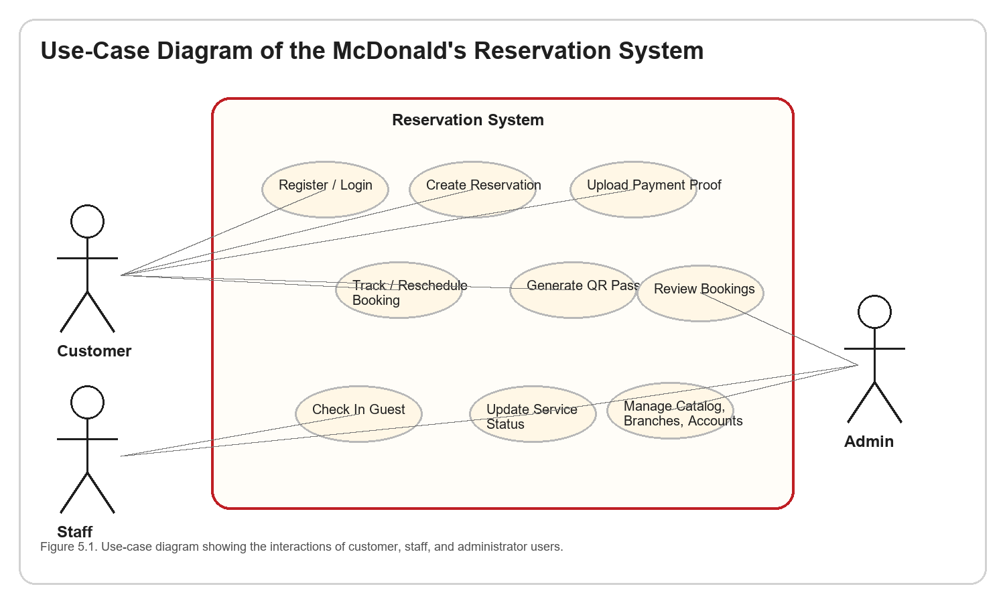
Figure 5.1. Use-Case Diagram of the McDonald's Reservation System
The use-case design shows that the system separates responsibilities according to user roles. This separation improves security and usability because customers only access booking-related functions, staff members access operational tools, and administrators access management functions.

b.) Class Diagram
The class diagram presents the main entities used by the system. The central class is Reservation because it connects the customer, branch, package, menu selections, payment proof, booking status, and service status. The User class represents customer, staff, and administrator accounts. The Branch class stores branch-specific details such as code, location, capacity, and supported event types. Other classes such as BookingPackage, MenuItem, AddOn, and BookingSetting support the reservation options and rules used during booking.
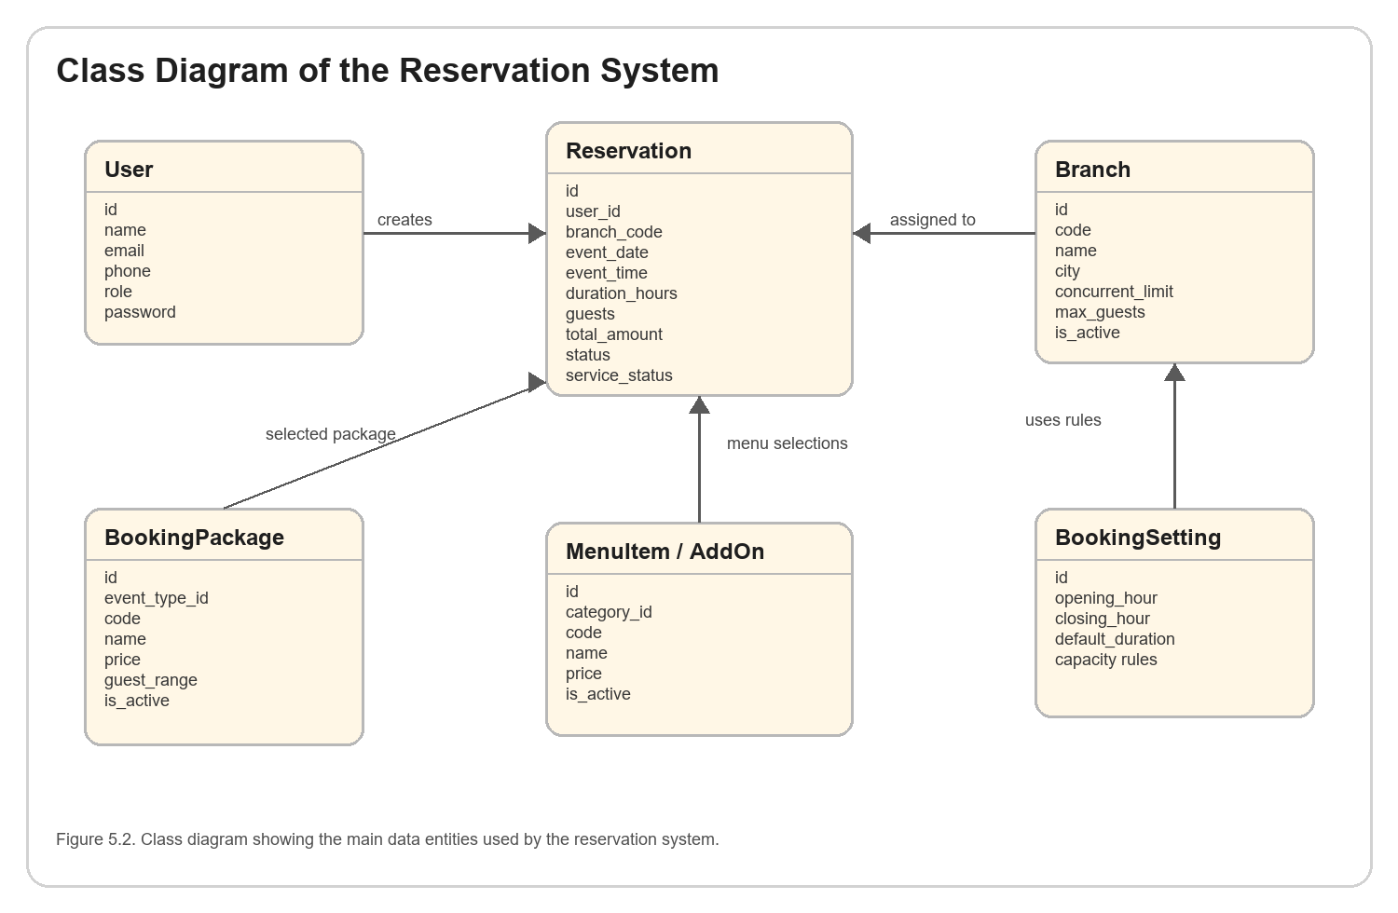s
Figure 5.2. Class Diagram of the Reservation System
This design supports maintainability because each major data concept is represented by its own model. Changes to packages, branches, menu items, or booking settings can be handled without changing the entire reservation structure.

c.) Sequence Diagram
The sequence diagram shows the process of creating a reservation. The customer enters booking details through the web or mobile interface. The interface submits the request to the Laravel backend, which validates the input, checks the booking rules, stores the reservation, and returns a booking reference. The booking is then displayed as pending until the administrator reviews and updates the status.
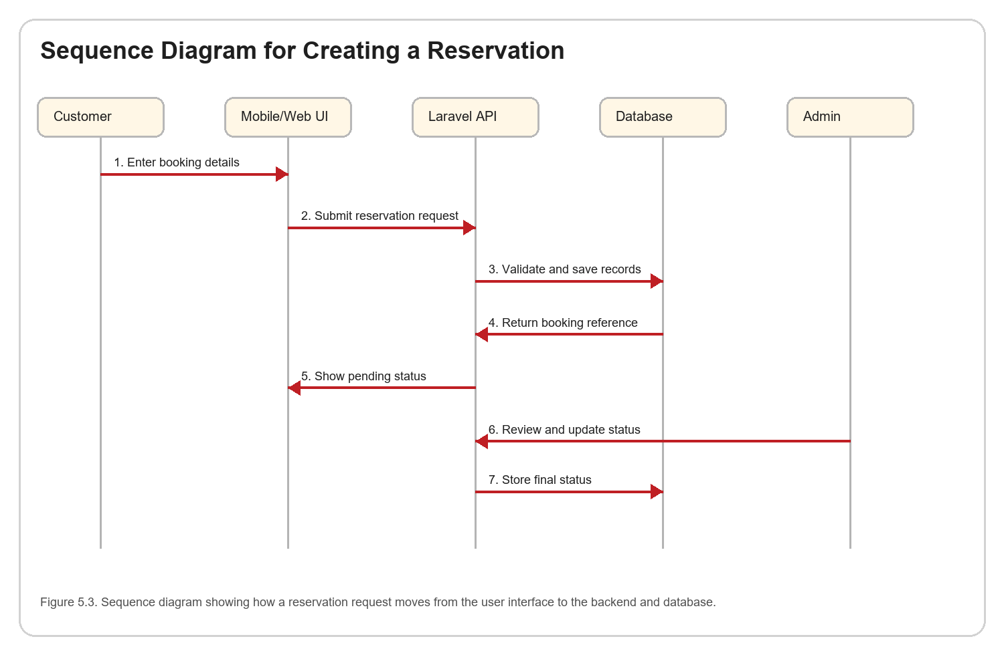
Figure 5.3. Sequence Diagram for Creating a Reservation
The sequence design confirms that the backend is responsible for validation and business logic. This is important because both the web and mobile applications depend on the same server-side rules when creating or updating reservations.

5.3 System Implementation
The system implementation resulted in a working Laravel web application and an Expo React Native mobile application. The Laravel backend handles authentication, routing, controllers, models, validation, reservation processing, payment proof upload, and database transactions. The Vue.js and Inertia.js web interface provides customer pages, booking forms, dashboards, staff pages, and administrator pages. The mobile application uses API endpoints to access the same reservation data and business rules.
The implemented customer module allows users to create an account, sign in, select event details, choose a branch and schedule, select a package, add menu items and add-ons, upload payment proof, submit the booking, view dashboard statistics, reschedule bookings, cancel bookings, and access booking pass information. These features address the need for a more convenient and traceable reservation process.
The implemented staff module supports operational tasks such as viewing today's bookings, checking in guests through a booking code, updating service status, and recording service adjustments. This helps staff members coordinate event preparation and update operational records without relying only on manual notes.
The implemented administrator module provides booking review, status updates, crew assignment, confirmed event tracking, branch management, catalog management, availability monitoring, report viewing, timeline tracking, and account management. The admin tools make it easier to maintain booking rules and monitor reservation activities across branches.

Implemented System Modules
Module | Implemented Features | Discussion
Customer Module | Registration, login, booking, payment proof upload, dashboard, reschedule, cancellation, and booking pass. | Supports self-service reservation and booking monitoring.
Staff Module | Daily bookings, check-in, service status, service adjustments, and preparation list. | Supports branch-level event operations.
Admin Module | Booking review, status update, crew assignment, catalog, branches, reports, availability, accounts. | Supports management and monitoring of reservation activities.
API Layer | Mobile login, booking options, dashboard, operations, profile, admin, and staff actions. | Connects the Android app to the Laravel backend.
Database Layer | Users, reservations, branches, event types, room options, menu items, add-ons, and settings. | Provides persistent storage for system records.

5.4 Evaluation of the System
The system was evaluated based on selected ISO/IEC 25010 software quality criteria, particularly functional suitability, usability, performance efficiency, reliability, and security. Internal testing was conducted by checking whether the major system functions worked according to the requirements defined in Chapter 4. The evaluation also considered whether users could understand the interface flow and whether important actions returned appropriate feedback messages.
In terms of functional suitability, the system was able to perform the main reservation-related functions such as account access, booking creation, payment proof upload, reservation review, staff check-in, and status updating. The use of shared backend logic for web and mobile helped maintain consistent behavior across platforms.
In terms of usability, the system used guided forms, card-based layouts, status badges, tab navigation, and clear action buttons to help users complete tasks. The mobile application was especially designed around short task flows, such as booking, dashboard checking, account access, and staff operations.
In terms of performance efficiency, the system used API requests, cached mobile data, and structured database queries to reduce repeated loading. The mobile dashboard and booking options include caching behavior so that users can still see recently loaded information while the app refreshes data from the server.
In terms of reliability and security, the system used validation, Laravel authentication, Laravel Sanctum tokens for the mobile API, protected routes, role-based access, and error handling. These controls help prevent unauthorized access and reduce failures caused by incomplete or invalid input.

Evaluation Summary
Quality Criterion | Observed Result | Discussion
Functional Suitability | Major customer, staff, and admin functions were implemented. | The system supports the reservation workflow from booking creation to admin review and staff operation.
Usability | Interface uses guided cards, labels, buttons, tabs, and status indicators. | The design helps users understand the current task and booking status.
Performance Efficiency | Mobile screens use API calls and caching for dashboard and booking data. | The app can reduce repeated loading while still refreshing live records.
Reliability | Validation and error messages are included in booking, login, and update actions. | The system can guide users when required fields or network requests fail.
Security | Authentication, role separation, and token-based mobile access are used. | Private customer, staff, and admin functions are protected.
The evaluation indicates that the system is appropriate for supporting digital reservation management. However, future testing with a larger number of respondents is recommended to obtain formal usability scores, task completion rates, and performance measurements under real operating conditions.

5.5 Android Mobile Application
The Android mobile application was developed using Expo, React Native, and TypeScript. Its current design follows the McDonald 's-inspired visual identity used in the project, including a yellow customer page background, a header with the McLogo, cream and white rounded cards, red primary action buttons, chip selections, metric tiles, and bottom tab navigation. The app is designed for customers who need quick booking access and for staff or administrators who need mobile operational tools.
The customer-facing mobile flow includes Home, Book, Dashboard, and Account tabs. The Home screen introduces booking options and entry points. The Book screen guides users through event type selection, branch selection, schedule and availability checking, room choice, package selection, menu bundle selection, manual menu item selection, add-on selection, notes, and payment proof upload. The Dashboard screen displays booking metrics and reservation cards, while the Account screen supports profile and session management.
The mobile booking screen reflects the actual system process. It loads booking options from the Laravel API, stores cached booking data, calculates available start times based on duration, allows customers to choose menu items and add-ons, and submits a reservation using FormData so that payment proof images can be uploaded. This makes the mobile app a practical extension of the web reservation system.
The mobile dashboard also uses API-based data loading and caching. It displays upcoming reservations, confirmed spend, pending approvals, booking reference numbers, branch information, event dates, event times, and booking status labels. Customers can refresh the dashboard, add a new booking, cancel a reservation, or submit reschedule details when allowed.
The operations screen provides mobile access for staff and administrators. Staff can check in guests and update service status, while administrators can update booking status, assign crew, manage users, branches, inventory, event types, packages, room options, and booking settings. This design allows selected operational and administrative functions to be accessed even outside the desktop web dashboard.
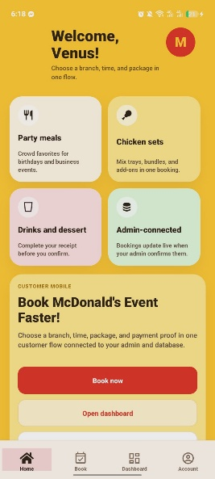
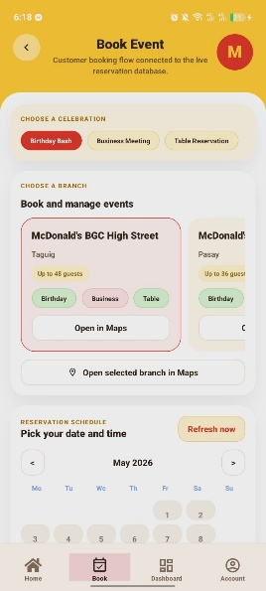
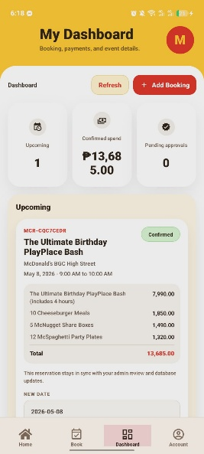
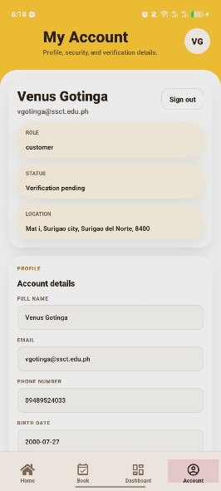

Figure 5.4. Android Mobile Application Design
Overall, the Android mobile application strengthens the proposed system by making the reservation workflow more accessible. Customers can create and monitor bookings from a phone, staff can handle check-in and service updates, and administrators can perform selected management actions through mobile API screens. This supports the project's goal of making the reservation process more organized, traceable, and convenient.

6. REFERENCES

6.1 Local References
Banas, A. R. M., et al. (2020). Web-based management system for catering services and event planning. https://repository.cpu.edu.ph/handle/20.500.12852/2278
Calpito, R., Salamat, L., & Mendoza, B. (2020). Web-based and mobile hotel reservation system with analytics. https://mseuf.edu.ph/research/read/1113
Capuno, M. I., Benigno, J. F., Reyes, R. G., & Tojino, K. C. M. W. (2021). iReserve: An online event reservation for Lipa City Cultural with SMS notification. https://ejournals.ph/article.php?id=16128
Caritos, J. A. L. (2024). Transformation of hotel reservation systems. https://stepacademic.net/ijcsr/article/view/446
Deocampo, J. V., et al. (2020). Online resort services management system. https://ejournals.ph/article.php?id=6112
Dublado, A. M. E., et al. (2020). Hotel guest management system. https://repository.cpu.edu.ph/handle/20.500.12852/1815
Esguerra, J. G., & Arreza, M. K. B. (2021). The motivational factors on using virtual hotel operators' accommodation among tourists in Cebu City, Philippines. https://jbhost.org/jbhost/index.php/jbhost/article/view/305
Felicen, S. S. (2024). Innovation practices in catering business. https://ejournals.ph/article.php?id=26351
Felicen, S. S., & Ylagan, A. P. (2020). Effects of computer reservation systems in travel agencies. https://research.lpubatangas.edu.ph/wp-content/uploads/2016/09/APJMR-2016.4.4.04.pdf
Leona, R. F. (2023). Development and assessment of AppStay reservation system. https://ejournals.ph/article.php?id=32526
Monterey, J. M. (2021). Service quality of online travel agencies in CALABARZON. https://research.lpubatangas.edu.ph/wp-content/uploads/2022/09/6-APJARSS-Monterey.pdf
Munoz, A. D. D. G. (2023). Influence of online reviews on Airbnb booking behavior. https://ejournals.ph/article.php?id=29702
Ramento, L. F., et al. (2024). Web-based reservation and management system for Nature Spring Resort. https://csu.org.ph/jpas/article/download/43/43
Sabaulan, J. S. (2023). Environmental practices of hotel industries in Santiago City. https://ejournals.ph/article.php?id=24903
Vega, M. M. (2024). Online facility reservation system. https://ejournals.ph/article.php?id=30627
Villanueva, E. (2024). Online reservation management system. https://doi.org/10.70838/pemj.360705

6.2 Foreign References
Abdullah, D., et al. (2020). Online hotel booking intention and perceived usefulness. https://www.iarjournal.com/wp-content/uploads/IARJSS2017_1_16-23.pdf
Deksne, L., Kempelis, A., Sniedzins, T., & Kozlovskis, A. (2021). Automated system for restaurant services. https://doi.org/10.7250/itms-2021-0003
Egigogo, R. A., et al. (2024). Design and implementation of computerized restaurant table booking system. https://journal.ceddi.id/index.php/jst/article/view/64
Gangurde, R., & Kshirsagar, P. (2024). Smart dining systems integrating reservations and food pre-ordering. https://www.jetir.org/papers/JETIR2504D51.pdf
Ganiyu, M., Egwuche, O. S., & Adekunle, K. O. (2024). Online events booking and reservation system. https://www.researchgate.net/publication/383272017_Online_Events_Booking_and_Reservation_System
Garcia, G. M., et al. (2024). Digital reservation platforms in hospitality. https://tmstudies.net/index.php/ectms/article/download/2518/2544/11396
Gaur, V. (2024). Online reservation systems in the hospitality industry. https://www.marketingjournal.net/archives/2024.v6.i1.A.291
Halkiopoulos, C., et al. (2020). Online reservation systems in e-business: Analyzing decision making in e-tourism. https://papers.ssrn.com/sol3/papers.cfm?abstract_id=3747958
Law, R., Leung, R., & Buhalis, D. (2020). Information technology applications in hospitality and tourism. https://doi.org/10.1080/10548400903163160
Mohd Roseli, N. A., & Hamid Ali, F. A. (2024). Book cafe online reservation system for Dino Bookcafe. https://publisher.uthm.edu.my/periodicals/index.php/aitcs/article/view/16664
Ozturk, A. B., et al. (2020). Mobile hotel booking loyalty and convenience. https://doi.org/10.1016/j.ijinfomgt.2016.04.005
Sahara, R. I., et al. (2024). Web-based reservation system for catering services. https://www.researchgate.net/publication/394595981_Development_of_a_Web-Based_Reservation_System_to_Improve_the_Efficiency_of_Catering_Services
Sahu, G., & Yadav, M. (2024). Restaurant reservation system. https://www.researchgate.net/publication/324987630_ONLINE_HOTEL_RESERVATION_AND_MANAGEMENT_SYSTEM_FOR_THE_COLLEGE_OF_INTERNATIONAL_TOURISM_AND_HOSPITALITY_MANAGEMENT_CITHM
Smith, R. P. (2020). Impact of online reservation systems. https://scholarworks.umass.edu/bitstreams/90d9d362-4b19-4d43-8517-e8a650223edd/download
Subrahmanyam, K., et al. (2021). Online table reservation with pre-ordering. https://turcomat.org/index.php/turkbilmat/article/download/1197/976/2200
Ullah, I. (2020). Customer satisfaction in online hotel booking. https://www.researchgate.net/publication/324987630_ONLINE_HOTEL_RESERVATION_AND_MANAGEMENT_SYSTEM_FOR_THE_COLLEGE_OF_INTERNATIONAL_TOURISM_AND_HOSPITALITY_MANAGEMENT_CITHM
Vlahovic, O., et al. (2024). Digital transformation in tourism and e-booking systems. https://doi.org/10.2478/crdj-2024-0012
Wu, M. (2020). Customers' perceptions of service quality in online reservation systems. https://dr.lib.iastate.edu/items/8b5c0d61-c2c0-4c77-99c3-8f95e95d7c91
Xue, P., Jo, W., & Bonn, M. A. (2020). Online hotel booking decisions based on price complexity and alternative attractiveness. https://doi.org/10.1016/j.jhtm.2020.08.013
Zezar, M., & Kalifa, A. (2024). QR code-based ordering and reservation system. https://www.researchgate.net/publication/324987630_ONLINE_HOTEL_RESERVATION_AND_MANAGEMENT_SYSTEM_FOR_THE_COLLEGE_OF_INTERNATIONAL_TOURISM_AND_HOSPITALITY_MANAGEMENT_CITHM

